Global disaster alert and coordination system (GDACS): Teacher note
When there are predictable extreme weather conditions we are often issued with warnings via text message, website announcements or social media. These warnings are often issued by the Australian Bureau of Meteorology. Another organisation that provides alerts is the Global Disaster Alert and Coordination System (GDACS). This organisation is a cooperation framework under the United Nations. Besides alerts GDACS also provides impact estimations.
If you have internet access, go to website Global Disaster Alert and Coordination System (GDACS) (United Nations and the European Commission) http://www.gdacs.org/ and look at the current extreme weather and geological events. Alternatively, take a screen shot of the site prior to the lesson to discuss with students. A screenshot is also provided below.
Students should be able to:
- recognise the severity of the disaster depending on whether it classified as a green, orange or red alert.
- identify the time, date and type of disaster
- the damage associated with the disaster.
Alerts are early warning systems that help communities prepare, respond to and reduce the impact of the natural disaster. Technological advances have greatly improved the quality and time frame of information about an extreme weather event. Early warning alerts can save lives but cannot prevent all the damage that an extreme weather event my cause.
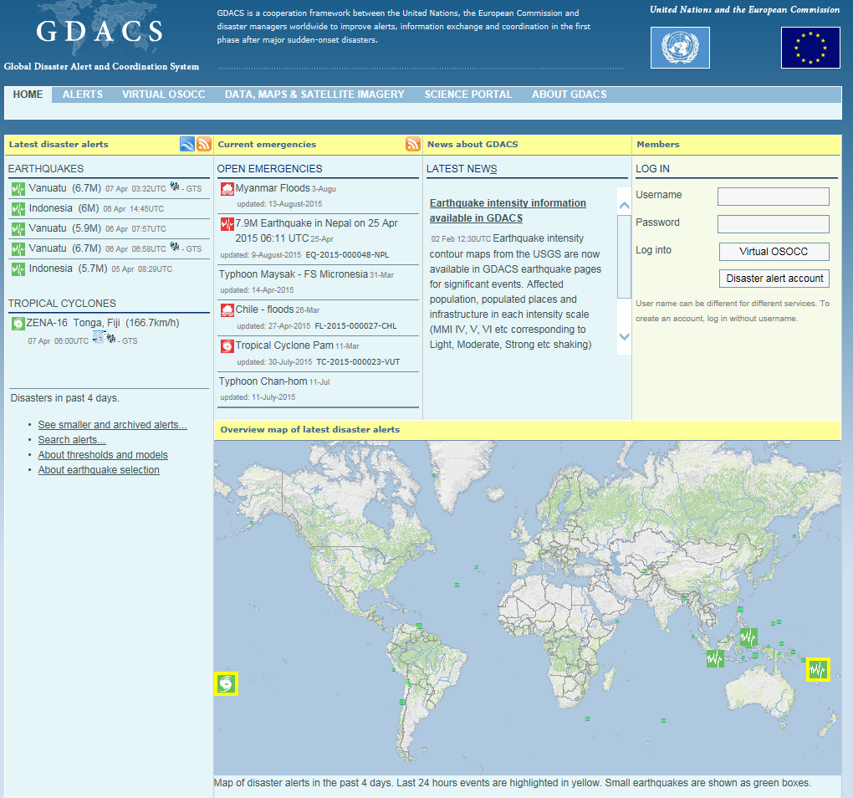
Source: Global disaster alert and coordination system (European Commission) http://www.gdacs.org/

